***PAAREES PERFUMES***

***THIERRY MUGLER***

***FOR WOMEN***

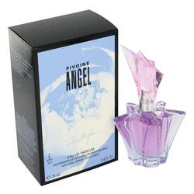

# 

***ANGEL PEONY***

## *Description:*

Angel Peony by Thierry Mugler Perfume. Enter a delightfully mystical world with the heavenly scent of Angel Peony, a fragrance for the playful woman who appreciates a touch of fantasy in her life. Created in 2005 by Thierry Mugler, this perfume features light woodsy notes mingled with fresh florals to create a scent that gently lingers and entrances, like a slow walk into a golden, sunlit meadow. Wear this soft, subtle fragrance anytime you want to feel the enchantment of nature or the allure that is yours and yours alone.